|  |  |  |  |  |
| --- | --- | --- | --- | --- |
|  |  | |  | | --- | | Panther  News | | August | |
| P |  |  |
| Panther Nation Update |  | In This Issue |

# **Principal Message**

The beginning of the school year is filled with lots of enthusiasm, renewed energy and high expectations. The first month of school will reinforce our expectations for the year – classes will be busy with students engaged in their learning. Thank you parents for helping your children prepare for a productive school year.

Here are a few reminders:

**Lines of Communication:** Communicate with your child’s teachers on a regular basis. I strongly encourage you to call or email your child’s teachers (their email can be found on the school website) as soon as possible to open the lines of communication to determine how you can work together to optimize your child’s academic success. Also, check parent portal often.

**School Support**: If you notice that your child is showing signs of academic, social or emotional, trouble, please contact their guidance counselor, support staff or the office right away. Don’t wait until your son or daughter starts to seriously struggle. We want to work together, as a team, to support your son or daughter.

**Preparedness**: Please, please encourage your child to make sure they come to school prepared EVERY DAY!! Students should come with pencils, paper, etc. It is very important to come PREPARED! Encourage your child to wear their school issued ID badge daily (**Issued after 1st 10 days**). IDs are a way to identify students and foster personal connection. Also encourage your child to use a daily planner. The purpose of a daily planner is to improve student achievement through the reinforcement of better preparation and organization skills and improve communication between students, parents, and teacher.

**Get Involved**: Finally, encourage your child to get involved in a school activity. There are a variety of activities such as: academic clubs, student government, etc. that students can choose from. Activities give students an opportunity to meet new people, explore something new and it fosters student engagement.

I am here to assist you to ensure that your child has a successful year. Do not hesitate to contact me at 298-1616 or by email at [mitchellto@pcsb.org](mailto:mitchellto@pcsb.org) or the Assistant Principal, Dr. Robyn Witcher, at 298-1616 or via email at [witcherr@pcsb.org](mailto:witcherr@pcsb.org)

Welcome Back Panthers! Have a Great Year.

Tonya Mitchell

Principal

Volunteer Information

PTA

Electronic Policy

Dress Code Policy

Parent Contact Information



### Be a Volunteer!

The opening of school is an exciting time for students, parents and teachers. We, at Clearwater Intermediate School are excited about the possibilities for the new school year.

Please consider volunteering at our school. Below are some ways to do so:

**Tutor**

Tutors assist students either on an individual basis or in small groups to re-inforce basic skills in academic subjects. Placements are made depending on what the tutor feels comfortable with.

**Mentor**

Mentors work with struggling students. By serving as role models, mentors can provide encouragement and friendship to a student needing to build self-esteem.

**Activities Volunteer**

Activities Volunteers lend a hand to support any special activities hosted by the school.

One example this year would be the school book fair held on the second week of school.

**Great American Teach-In**

The Great American Teach-In is part of the American Education Week celebration. It is a special opportunity for you to visit our school and share what you know with a group of students. This year’s event in scheduled for Wednesday, November 17th. At this time this event will be virtually. Please consider participating!

We hope that you will consider volunteering at our school in some way. Volunteer registration forms are available in the front office, or from the school’s Family and Community Liaison.

Family and Community Liaison

(727) 298-1616 X2045



Students can access the I-ready reading program from a home computer that has internet.

**Keep Reading all those great books!**

In an effort to promote high student achievement, we are offering additional support to our students through our Extended Learning Program (ELP). This program is available before school (8:15 – 8:45 am) on Tuesdays and Wednesdays for tutoring or course recovery.



**WHAT is PTA and WHY Should we have it at our School?**

PTA is the largest non-profit voluntary association committed solely to children and youth. Organized in 1897, its basic concern has always been to create a better life for every child. In the process, PTA has united parents, teachers, administrators, legislators and communities in this effort. The concerns have changed and evolved, but the Purposes of PTA have remained the same.

In PTA, we have a united purpose, a higher goal. All of us working together can make a tremendous difference…for all children and young people everywhere.

PTA membership is open to everyone. PTA is inclusive of all people who care about children and schools. PTA builds bridges between homes, schools, and communities to help children succeed academically and personally.

PTA is a united national voice for children. Not all decisions affecting a child’s school happen at the local level, and the Mission of PTA is to address the educational and social needs of all children. For more than a century, PTA has been a driving force in national education policies and programs. Today, PTA continues to champion the importance of parent/family involvement, safe and nurturing environments, and proper funding, curriculum, and leadership in our public schools.

Be a part of that mission. Let’s build a strong PTA at our school to help our students and all children! We can make a difference one child at a time.

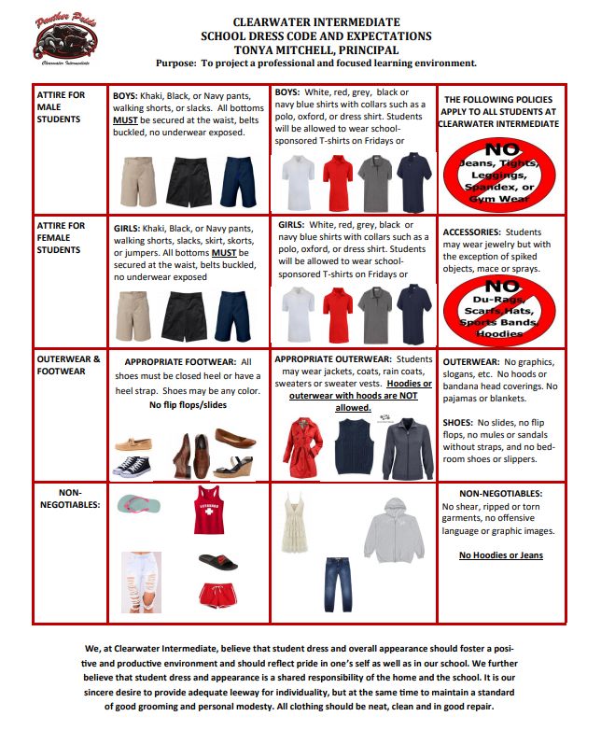



**Dress Code Policy**

**Students should wear clothing as it is designed to be worn; pants and skirts must be worn at waist level.**

**Tops**

* White, red, grey, black or navy blue shirts with collars such as a polo, oxford, or dress shirt
* Students will be allowed to wear school-sponsored T-shirts on Fridays or school spirit days
* Shirts must overlap the top portion of lower garments or bottoms (No exposed midriff)
* **NO HOODS (Tops or Jackets)**

**Bottoms**

* Khaki, Black, or Navy pants, walking shorts, slacks, skirt, skorts, or jumpers
* All items work at the waist (belts when needed)
* All bottoms must be knee length or longer
* No torn, baggy, form fitting clothing allowed
* **NO JEANS**

**Shoes**

* Remain consistent with PCSB Student Code of Conduct
* No flip flops/slides

**Backpacks**

* Mesh or Clear preferred

**Electronic Device Policy**

Clearwater Intermediate recognizes that the appropriate use of electronic devices can provide great potential for enhanced learning opportunities for all students. **However**, there are many other uses of electronic devices which can be a major distraction from the learning process; thus **the use of electronic devices while on Clearwater Intermediate campus is prohibited**. **All electronic devices** are required to be check in at the beginning of the school day before students enter the building. Electronic devices will be housed in a pre-labeled bag which will be stored in the front office. Electronic devices will be returned at the end of the day.

DOES PINELLAS COUNTY SCHOOLS

HAVE YOUR CORRECT CONTACT INFO?

**Don’t Miss Out on Important Information!**

Parents can now log onto the Student Reservation system to update their phone numbers and email addresses

Providing up-to-date contact information will enable you to receive:

* Communications about emergencies or severe weather events
* Timely information about school or district events
* Information and status updates about choice and other special application opportunities

**To update your information:**

1. Visit https://reservation.pcsb.org and log in with your parent username (P.xxxxxx) and password. If you do not have a parent ID, you can get one by going to any school and presenting a valid photo ID.
2. Select the option: “Change Phone and Email Address Only”
3. Enter your child’s name and date of birth or student ID number, and then update your phone number and email address.

**Remember**: Updating the emergency contact card at your child’s school does not update your contact information in the system used for automated phone calls and emails.

**Please check and update your contact information as soon as possible.**

**Questions? Call the Student Assignment Office at 727-588-6210.**